"Explore the Best of Sikkim & Darjeeling”
(6N/7D)

Discover the enchanting beauty of Sikkim and Darjeeling on this unforgettable 7 Days / 6 Nights journey through the Eastern Himalayas. Explore the charming hill stations of Darjeeling, Pelling, Yuksom, and Gangtok, each offering breathtaking landscapes and unique cultural experiences. Witness the spectacular sunrise over Mt. Kanchenjunga from Tiger Hill, visit ancient monasteries, and admire the stunning Tsomgo Lake nestled amidst snow-capped mountains.

Experience the serenity of Yuksom, the first capital of Sikkim, and the scenic beauty of Ravangla's Buddha Park. From lush tea gardens and peaceful valleys to vibrant local markets and panoramic mountain views, every destination offers a memorable experience. Perfect for families, couples, honeymooners, and nature enthusiasts, this itinerary promises the ideal blend of nature, heritage, and adventure in the heart of the Himalayas.

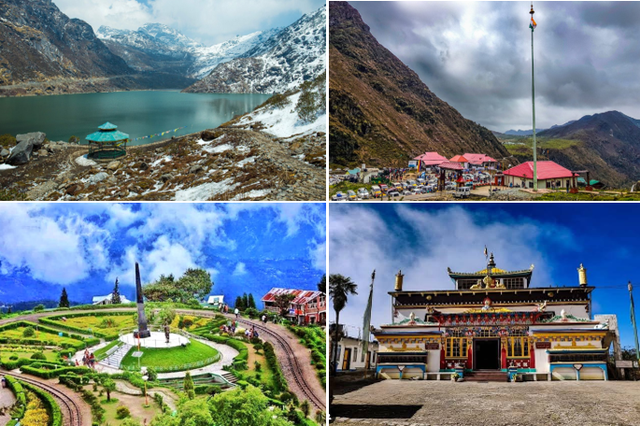
We wish you a happy, safe and unforgettable journey with us
Detailed Itinerary
Day 1: NJP / Bagdogra – Darjeeling (68 Km | 3 Hrs approx.)
Upon arrival at New Jalpaiguri (NJP) Railway Station or Bagdogra Airport, meet our representative and drive to the picturesque hill station of Darjeeling. Enjoy a scenic journey through lush tea gardens, winding mountain roads, and breathtaking Himalayan landscapes. Upon arrival, check in to your hotel and spend the evening at leisure exploring the local markets or the famous Mall Road. Overnight stay in Darjeeling.
Day 2: Darjeeling Sightseeing
Early in the morning, visit Tiger Hill to witness the spectacular sunrise over Mt. Kanchenjunga (weather permitting). On the way back, visit the historic Ghoom Monastery and the famous Batasia Loop, offering panoramic mountain views. After breakfast, continue sightseeing with visits to the Himalayan Mountaineering Institute, Padmaja Naidu Himalayan Zoological Park (closed on Thursdays), a Tea Estate, and the Tibetan Refugee Self-Help Centre (subject to time). Return to the hotel for an overnight stay in Darjeeling.
Day 3: Darjeeling – Pelling (70 Km | 3 Hrs approx.)
After breakfast, check out of the hotel and drive to the charming town of Pelling, known for its magnificent views of the Kanchenjunga range. En route, enjoy the scenic beauty of lush valleys, forests, and rivers. Upon arrival, check in to your hotel and spend the evening at leisure, soaking in the peaceful surroundings. Overnight stay in Pelling.
Day 4: Pelling – Yuksom (41 Km | 2 Hrs approx.)
After breakfast, explore the attractions of Pelling, including the Pemayangtse Monastery, Rabdentse Ruins, Chenrezig Statue, and the famous Pelling Skywalk, offering spectacular mountain views. Later, drive to the historic town of Yuksom, the first capital of Sikkim, surrounded by pristine forests and scenic landscapes. Upon arrival, check in to your hotel and relax. Overnight stay in Yuksom.
Day 5: Yuksom – Gangtok via Ravangla (116 Km | 4.5 Hrs approx.)
After breakfast, check out and drive to Gangtok via the beautiful town of Ravangla. En route, visit the famous Buddha Park (Tathagata Tsal), home to the magnificent 130-foot Buddha statue set against the backdrop of the Himalayas. Continue your scenic drive to Gangtok, the vibrant capital of Sikkim. Upon arrival, check in to your hotel and spend the evening exploring the lively MG Marg. Overnight stay in Gangtok.
Day 6: Gangtok Sightseeing
After an early breakfast, proceed for a full-day excursion to the beautiful Tsomgo Lake, a glacial lake nestled at an altitude of approximately 12,400 ft. Continue to the revered Baba Harbhajan Singh Mandir, an important pilgrimage site dedicated to an Indian Army soldier. If permits are available, you may also opt to visit Nathula Pass (at an additional cost). Return to Gangtok in the evening for an overnight stay.
Day 7: Gangtok – NJP / Bagdogra Departure (132 Km | 4.5 Hrs approx.)
After breakfast, check out of the hotel and drive to New Jalpaiguri (NJP) Railway Station or Bagdogra Airport for your onward journey. Depart with unforgettable memories of the snow-capped Himalayas, peaceful monasteries, scenic tea gardens, glacial lakes, and the natural beauty of Sikkim and Darjeeling. We wish you a safe journey and look forward to welcoming you again for another memorable holiday.
Tour ends with unforgettable memories

Destination/Nights | 3* Hotel Name
Darjeeling / 02N
Pelling / 01N
Yuksom/ 01N
Gangtok / 02N
HOTELS DETAILS:

Package Cost:

3★ Hotels: Rs. per person (Based on 6 guests – Double Sharing Basis)

Inclusion: -
- Breakfast and Dinner Included.
- 0 DBL Room on sharing based.
- 06 Nights in Accommodation in hotel.
- Assistance on Arrival.
- All Transfers and S.S tours by AC Tempo Traveler
Exclusions: -
- 5% GST.
- Flight Tickets are not included.
- Guide.
- Extra meal not included or as per the inclusions given above.
- Vehicle not at disposal.
- No extra pickup or drop included for lunch/sightseeing unless otherwise mentioned in the itinerary.

